**Inferential Statistics (Cont.)**

**Open this link and download the file(s)**

[**https://drive.google.com/open?id=1aL-bpqmh4jyJSgzRR_p2xqts5rBf0xef**](https://drive.google.com/open?id=1aL-bpqmh4jyJSgzRR_p2xqts5rBf0xef)

*-Story of William Gossett (Brewery of Guinness)*

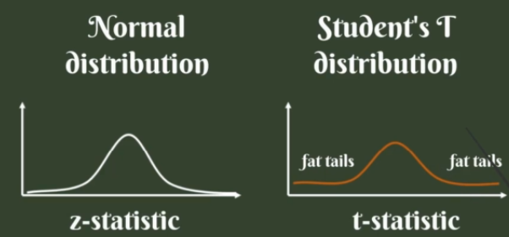

-Degrees of freedom (d.f)

-T-table (Used for Smaller Samples & Population variance unknown)

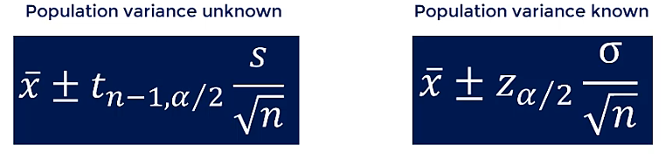

**Margin of Error (M.E):**



Smaller M.E: Narrower CI

Larger M.E: Wider CI

**We can control Margin of Error:**

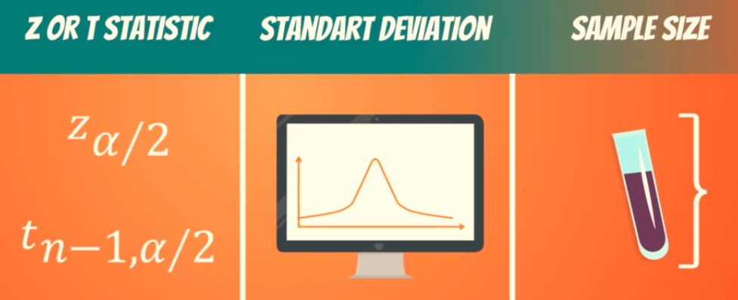

**Confidence Intervals (Two means):**

-Dependent Samples

-Independent Samples

**Dependent Samples:**

-Researching same subject overtime (E.g. Blood Samples, Weight Loss)

**Independent Samples:**

-Researching different subjects

Three types:

1. Population Variance Known (E.g. Different Department Percentages in University)

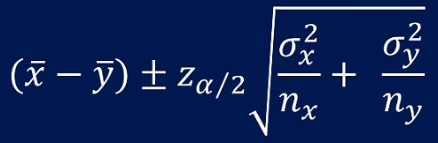

1. Population Variance unknown but assumed to be equal (E.g. Prices of mangoes in Karachi and Mirpurkhas)

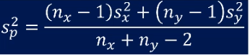

Pooled Sample Variance

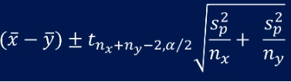

Ci Formula

1. Population Variance unknown and assumed to be different (E.g. Comparing Apples and oranges)